Q1) WAP that accepts the marks of 5 subjects and finds the sum and percentage marks obtained by the student.

Q2) WAP that calculates the Simple Interest and Compound Interest. The Principal, Amount, Rate of Interest and Time are entered through the keyboard.

Q3) WAP to calculate the area and circumference of a circle.

Q4) WAP that accepts the temperature in Centigrade and converts into Fahrenheit using the formula C/5=(F-32)/9

Q5) WAP that swaps values of two variables using a third variable.

Q6) WAP that checks whether the two numbers entered by the user are equal or not.

Q7) WAP to find the greatest of three numbers.

Q8) WAP that finds whether a given number is even or odd.

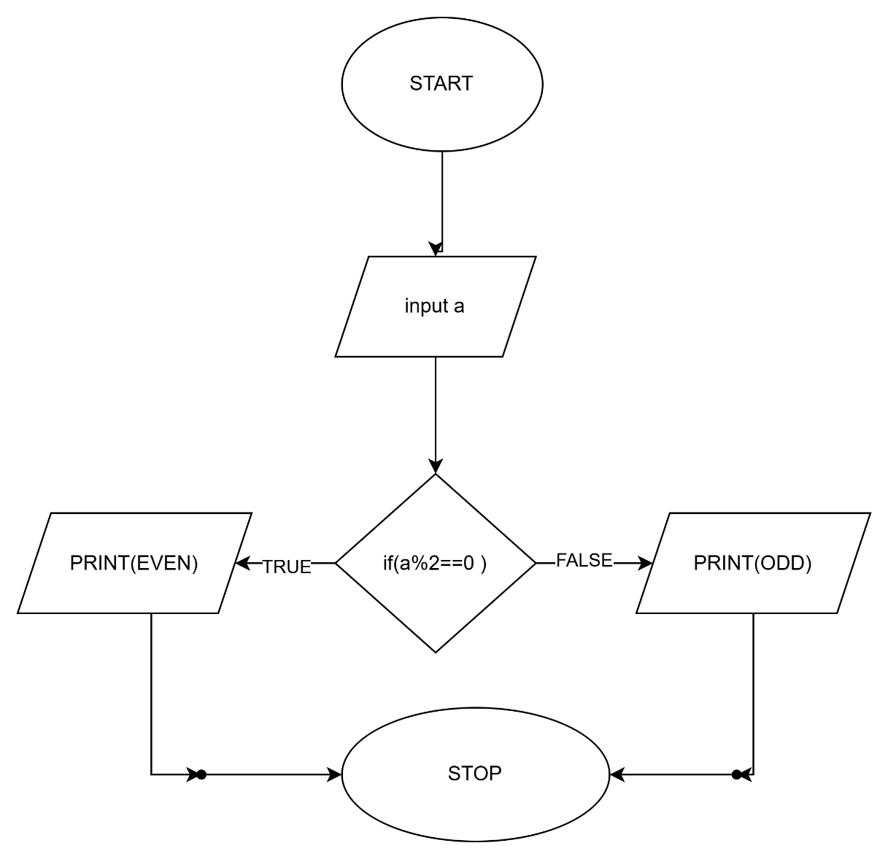

Q9) WAP that tells whether a given year is a leap year or not.

Q10) WAP that accepts marks of five subjects and finds percentage and prints grades according to the following criteria:

Between 90-100%--------------Print ‘A’

80-90%--------------------------Print ‘B’

60-80%---------------------------Print ‘C’

Below 60%----------------------Print ‘D’

Q11

Q12

Q13)

Q14)

Q17)

Q15)

Q16)

